**Creating Capcha in your Application using google Re-Captcha**

**1.Open the below link and Click GET reCAPTCHA Link**

**http://www.google.com/recaptcha**

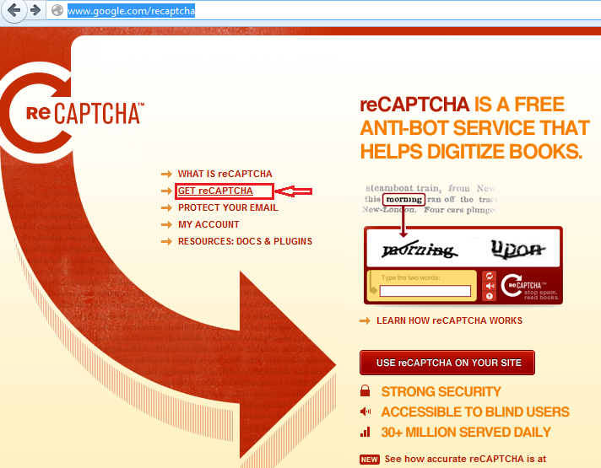

**2. Click on "Sign up Now!" button and signup to Your gmail Account inorder to use Re-Captcha**

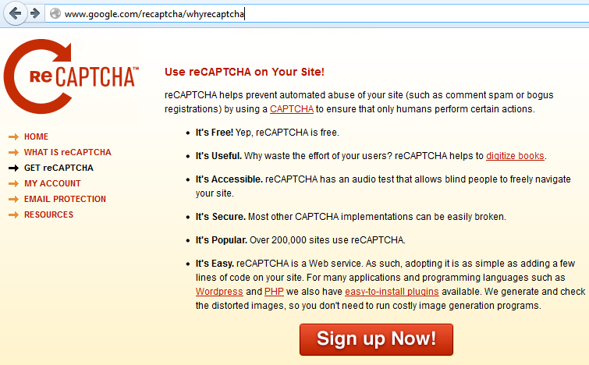

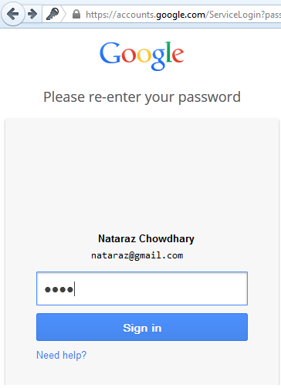

**3.Create a reCAPTCHA Key.Enter a domain(can be anything,non-existing as well),Select Enable this key on all domains.Otherwise the capcha will work only on your domain,if you want to use them in all other domains you must select them as well.**

**Click on create Key.**

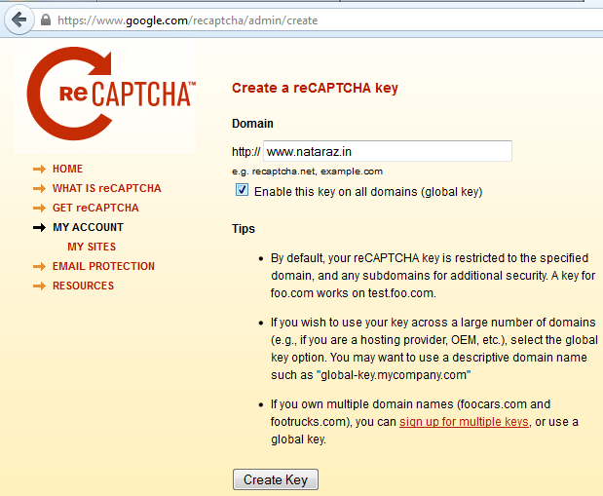

**4.The above step will generate private and public key for captcha**

**public key:** 6LfwU-kSAAAAANon6jhYZbfeeH-vgCKncnzs9WOr

**private Key:** 6LfwU-kSAAAAAGiis8gP7kS42ty9Wt_1euOGzj3J

**us**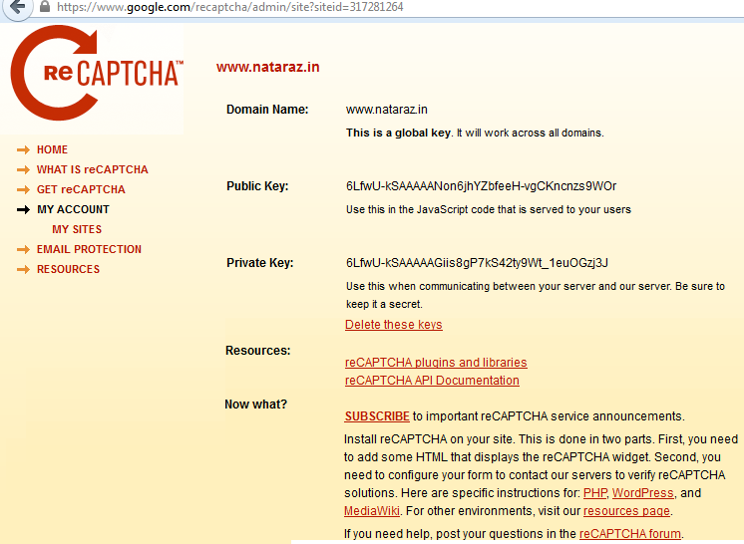

**5.We are now going to use those private and pubic key in our java application inorder to generate captcha.**

**Download the re-Captcha library from the below link**

**http://code.google.com/p/recaptcha/downloads/list?q=label:java-Latest**

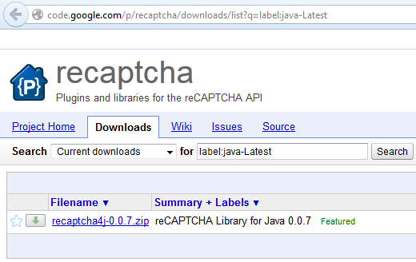

**6.Create a New web Project.Include the jars into the project**

**To show the image in index.jsp.Include the following**

<%@ page import="net.tanesha.recaptcha.ReCaptcha" %>  
    <%@ page import="net.tanesha.recaptcha.ReCaptchaFactory" %>  
  
    <html>  
      <body>  
        <form action="process.jsp" method="post">  
        <%  
          ReCaptcha c = ReCaptchaFactory.newReCaptcha("your_public_key", "your_private_key", false);  
          out.print(c.createRecaptchaHtml(null, null));  
        %>  
        <input type="submit" value="submit" />  
        </form>  
      </body>  
    </html>

**To Process the answer in process.jsp**

<%@ page import="net.tanesha.recaptcha.ReCaptchaImpl" %>  
    <%@ page import="net.tanesha.recaptcha.ReCaptchaResponse" %>  
  
    <html>  
      <body>  
      <%  
        String remoteAddr = request.getRemoteAddr();  
        ReCaptchaImpl reCaptcha = new ReCaptchaImpl();  
        reCaptcha.setPrivateKey("your_private_key");  
  
        String challenge = request.getParameter("recaptcha_challenge_field");  
        String uresponse = request.getParameter("recaptcha_response_field");  
        ReCaptchaResponse reCaptchaResponse = reCaptcha.checkAnswer(remoteAddr, challenge, uresponse);  
  
        if (reCaptchaResponse.isValid()) {  
          out.print("Answer was entered correctly!");  
        } else {  
          out.print("Answer is wrong");  
        }  
      %>  
      </body>  
    </html>